**What India’s Skilling Ecosystem got up-to on World Plumbing Day!**

Dear Readers,

Do you know when was the first sewage disposal and drainage system introduced? It was way back in 1700 BC. Okay, let me ask another question! Any idea about the first man in the world to receive a patent for a flushing toilet? It was Scotsman Alexander who received the first patent for flushing toilets in the year 1775. Enough of Trivia, for now, let me just come back to the point.

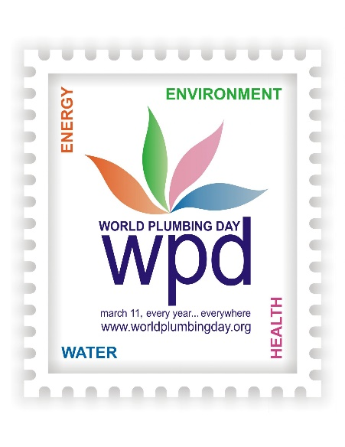As per the World Health Organization, poor sanitation is believed to be the main cause of approximately 4,32,000 deaths every year. I’m sure you’ll all agree that’s too much! Gradually, we all have realized that sanitation is an important factor in maintaining the health of a Nation. Our Hon’ble Prime Minister Sh. Narendra Modi realized this as well and that’s why the Swachh Bharat Mission was launched in 2014 on a large scale across India. However, people all over the world still lack awareness about Plumbing and its effects on health and hygiene. And that is why the World Plumbing Council observed World Plumbing Day on 11th March 2010 for the first time. WPC has always been working with its member countries and its partnership bodies like WHO all year round to promote the benefits of safe plumbing, but in 2010 it was decided to launch the concept of embedding a single day on the world’s calendar, dedicated to plumbing.

Indian Plumbing Skills Council has proudly taken part in all the initiatives that are directly or indirectly linked with the upliftment of the Plumbing Sector in India. As an Organization working towards skilling and upgrading the plumbing community of India, our eco-system has always carried out multiple activities each year to celebrate the World Plumbing Day. This year was no different and IPSC’s affiliated training partners celebrated World Plumbing Day in different parts of the country. Ashirvad Plumbing School in Bengaluru celebrated the event by organizing a poster making competition, a plumbing skills competition and a skit contest in their premises. The motive behind conducting all these activities was to educate the students about the vital role of Plumbing. One of our training partners, Pratham Education Foundation, carried out some fabulous activities to celebrate World Plumbing Day as well. In the Panvel district of Maharashtra, they organized two free Plumbing Service camps and an Awareness Rally. In the Ahmednagar district of Maharashtra, the TP organized a free plumbing service camp at a police station and an awareness rally regarding water conservation. Pratham Education Foundation also demonstrated simple domestic water-conservation methods to the public in Raipur, Chhattisgarh. Same camps were organized by the organization in Odisha as well. Our training Partner E-Biz Technocrats Pvt. Ltd. celebrated the day with the same energy. The Training Partner carried several activities across its centers in Madhya Pradesh & Uttar Pradesh. Some Government Schools in West Bengal also carried out awareness initiatives and painting competitions highlighting the importance of Plumbing. IPSC has been carrying out assessments in these schools as part of school vocational education, led by the states’ school board.

Before Concluding, I would like to draw your attention to a fact that 900 million school children across the world have no handwashing facilities. 6 in 10 people lack safely managed sanitation, 3 in 10 people worldwide lack access to safe, readily available water at home. The numbers are alarming and there is no doubt that the entire world is combating this, however we need to be more pro-active to counter the numbers. And dedicated days like World Plumbing Day are proving to be catalysts in spreading awareness regarding Plumbing not only in India but across the World.

*From:*

*Mr Vinay Gupta, Vice-Chairman, Indian Plumbing Skills Council (vg@ipssc.in)*

*Mr Vinay Gupta is a technocrat from IIT Delhi and has been manufacturing premium range of Tap ware in Delhi since last 35 years. Mr Vinay Gupta commenced the first ever production of Single Lever Mixers with ceramic cartridges in the year 1986 in India and has the distinction of manufacturing them in India and exporting back to Germany. He is also one of the largest exporters of Bathtubs. Mr. Vinay Gupta is the Founding Members of the Indian Plumbing Association (IPA) and Indian Plumbing Skills Council (IPSC). As the Vice Chairman of IPSC, Mr Vinay Gupta has been spearheading the development of the robust and sustainable eco-system of Skill Development in Plumbing with the Government of India.*

***Ebiz Technochrats***

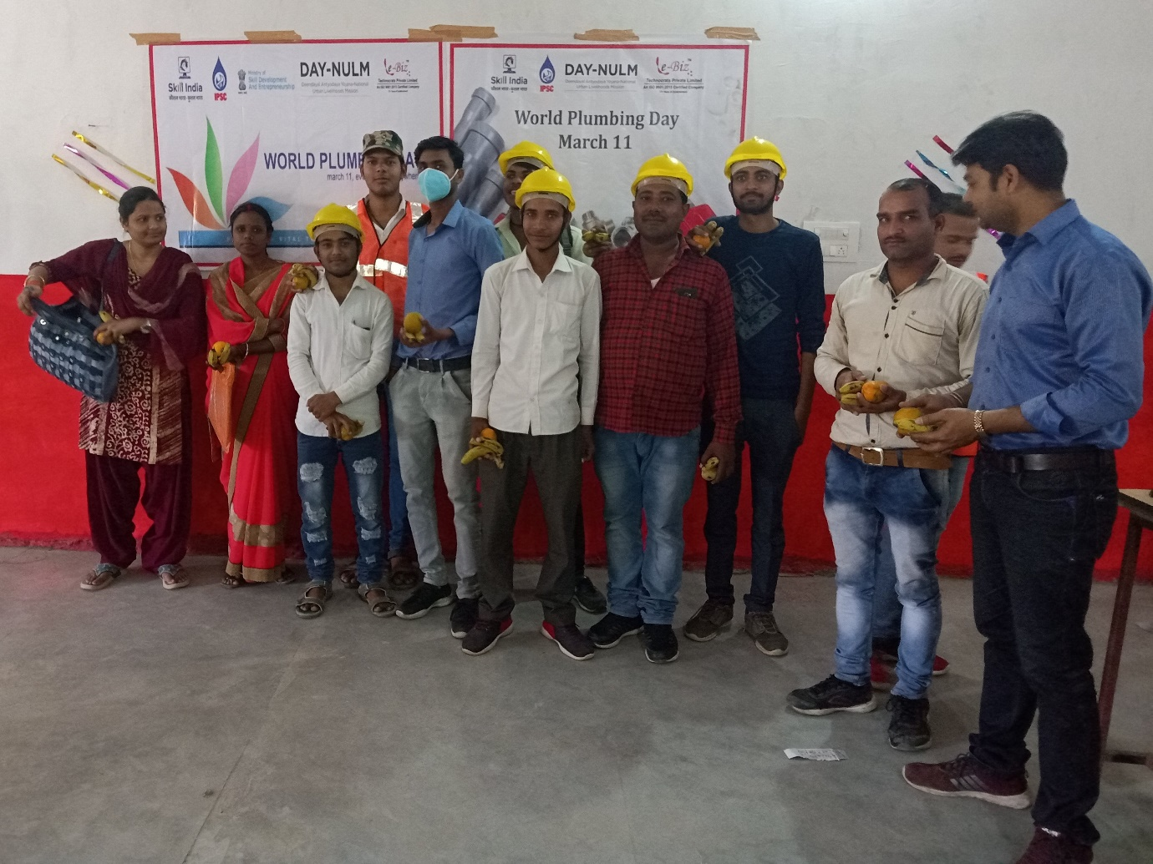

***West Bengal Schools***

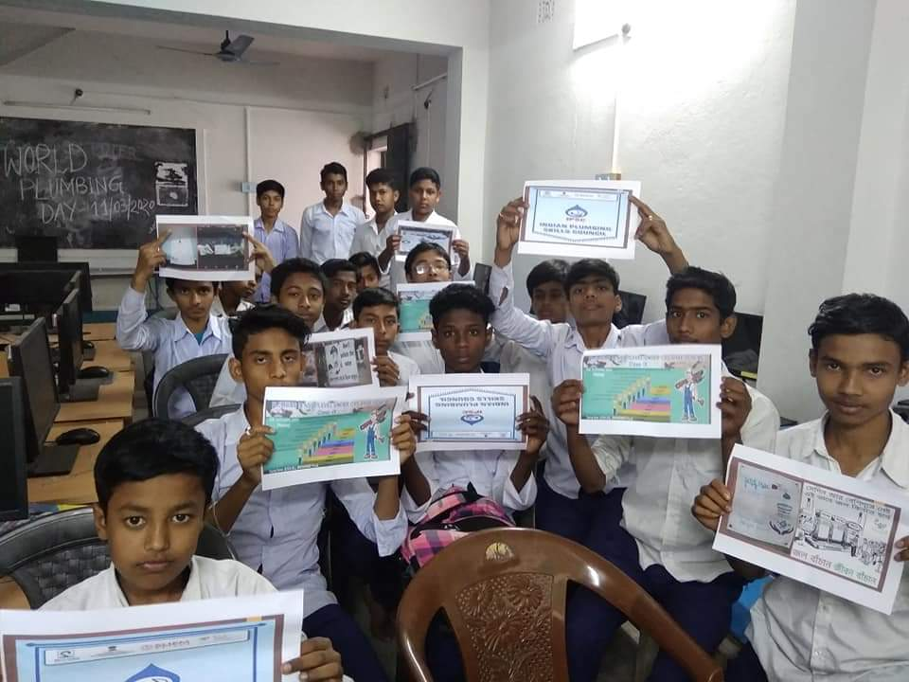

***Pratham Education Foundation***

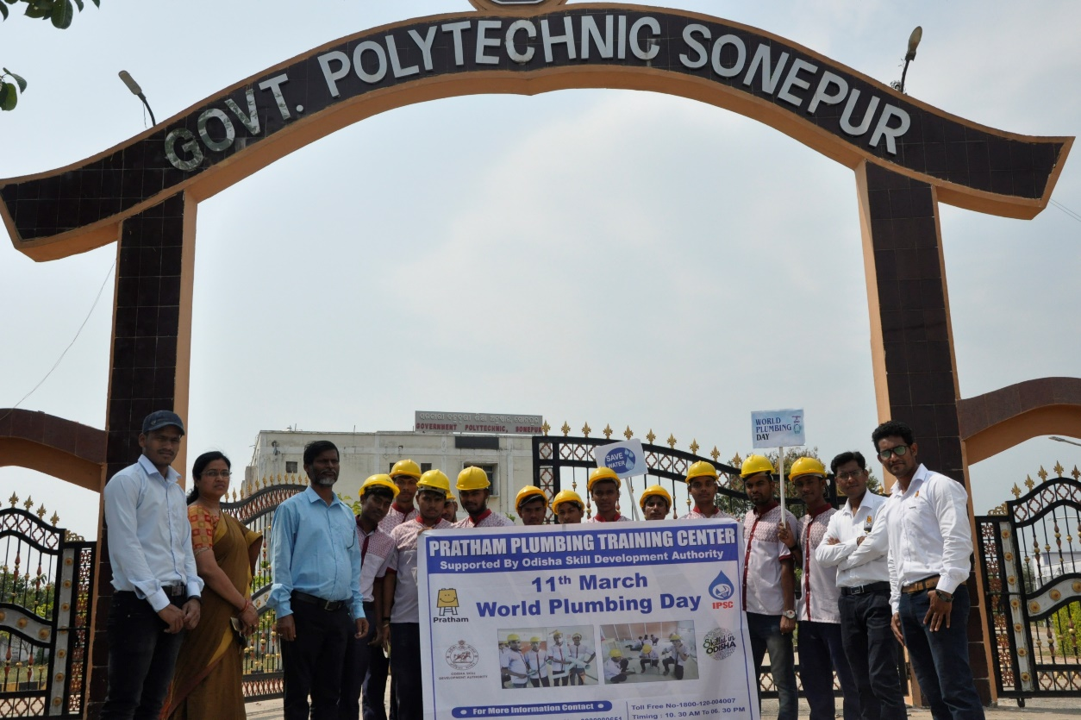

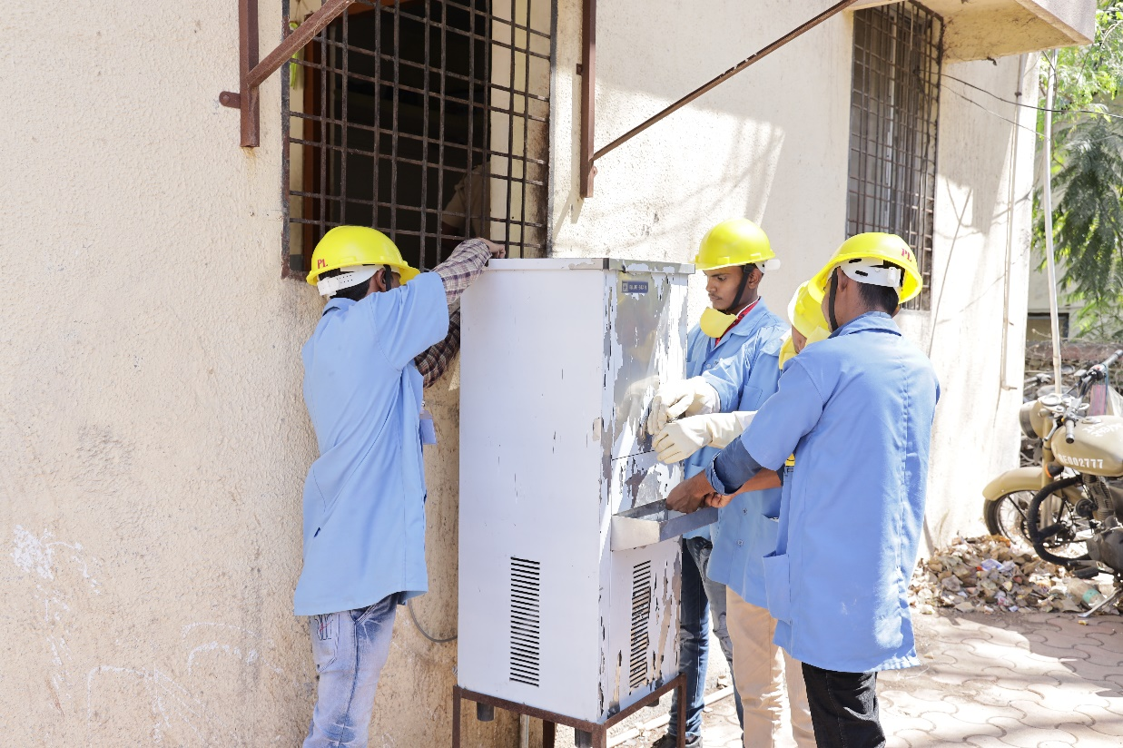

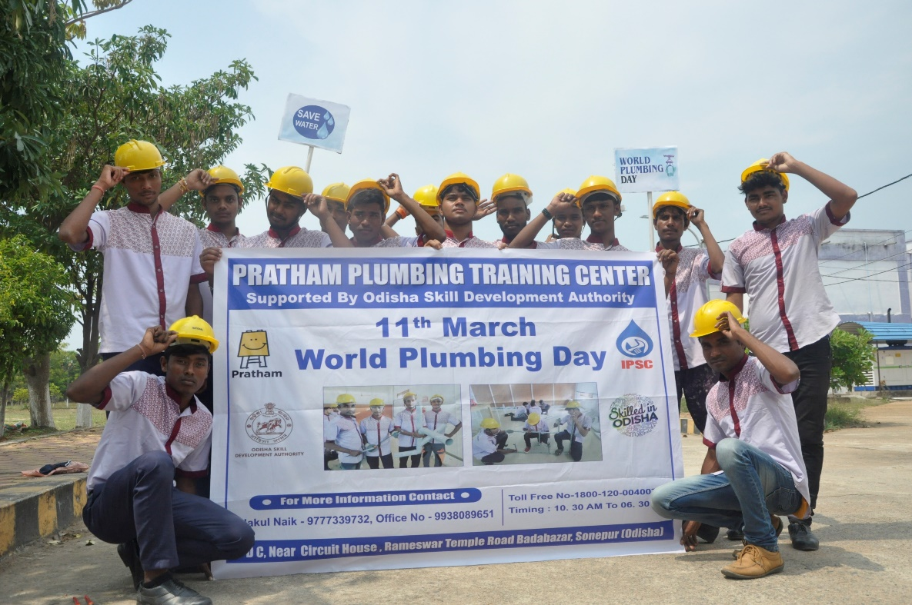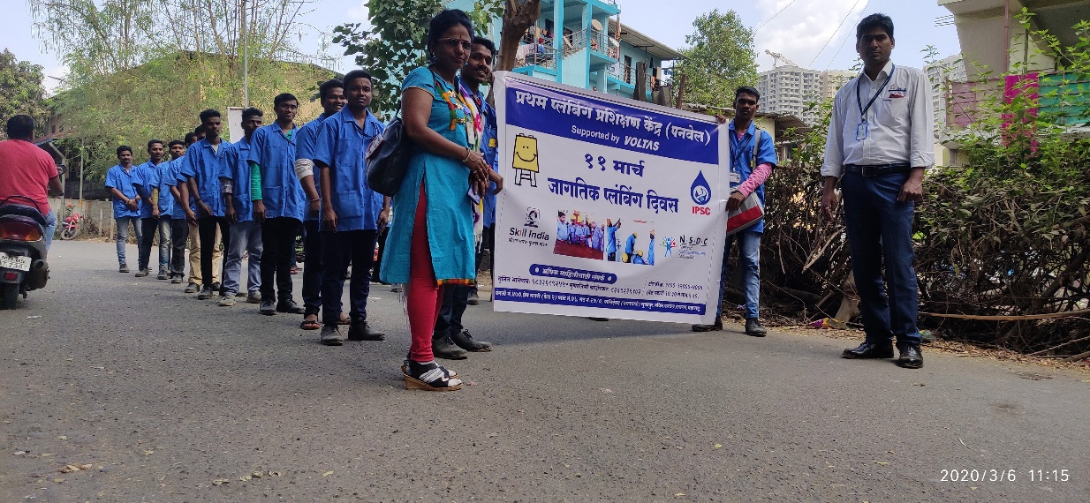

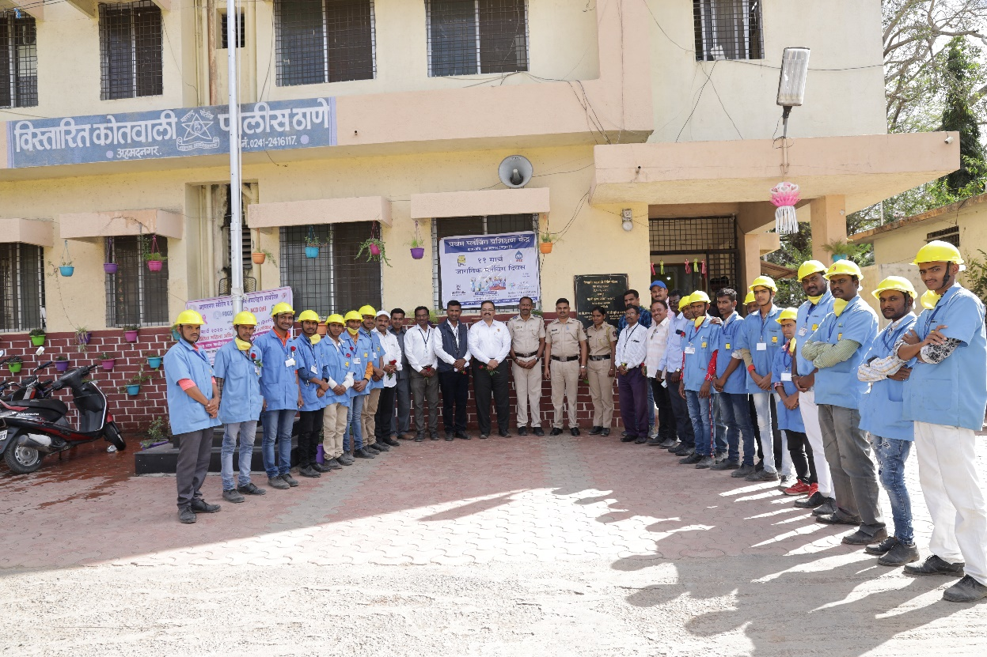

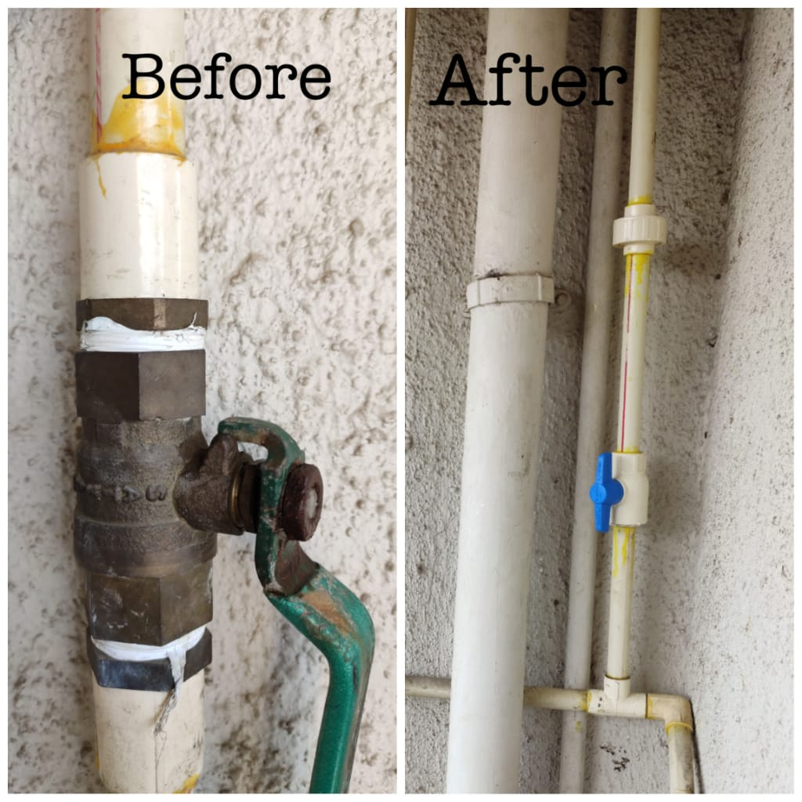

***Facts Inphographic by IPSC:***

